

CSA0501-DATABASE MANAGEMENT SYSTEMS

LAB EXPERIMENTS DATE: 12/07/2026

EXPERIMENT 3 – DML Commands (INSERT, SELECT)

AIM:
To perform Data Manipulation Language (DML) commands such as INSERT and SELECT in the Pet Management System database.

PROCEDURE:
- Open MySQL and create the Pet Management System database.
- Create the pet_details table with appropriate attributes.
- Use the INSERT command to add pet records into the table.
- Execute the SELECT command to display all pet records.
- Verify that the inserted data is displayed correctly.
- Observe the output and ensure the DML commands are executed successfully.

PROGRAM:

1. CREATE TABLE:

CREATE TABLE pet_details (

sno INT PRIMARY KEY,

pet_name VARCHAR(30),

pet_breed VARCHAR(40),

age VARCHAR(20),

food VARCHAR(30),

place VARCHAR(30),

total INT

);

OUTPUT:

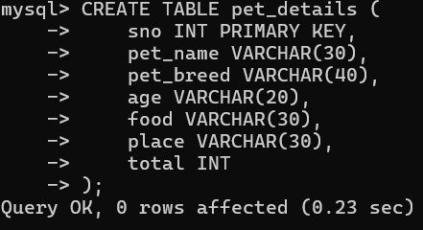

2. INSERT VALUES:
INSERT INTO pet_details VALUES
(1,'Rudra','Lab','3 months','Pedigree','Kuppam',5),
(2,'Snoofy','German Shepherd','1 year','Pedigree','Rajamundry',1),
(3,'Chichu','Guinea Pig','2 weeks','Vegetables','Chittoor',6),
(4,'Hulk','Tortoise','1 month','Vegetables','Singapore',3),
(5,'Battu','Hen','2 weeks','Rice','Chittoor',10),
(6,'Tiger','Pit Bull','1 year','Nonveg','Chennai',1),
(7,'Luna','Cat','6 weeks','Milk','Kuppam',2),
(8,'Shela','Betta Fish','1 month','Fish Food','Pondicherry',5),
(9,'Tommy','Golden Retriever','1 year','Pedigree','Chennai',1),
(10,'Hucky','Beagle','1 year','Pedigree','KGF',1);

OUTPUT:

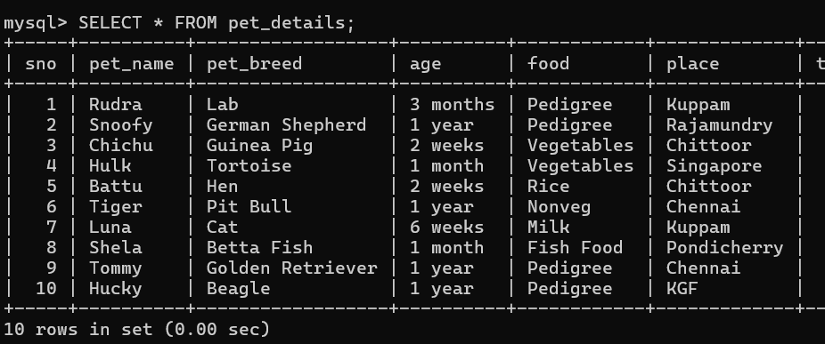

3. INSERT COMMAND:
SELECT * FROM pet_details;

INSERT INTO pet_details
(sno, pet_name, pet_breed, age, food, place, total)
VALUES
(11,'Bruno','Labrador','8 months','Pedigree','Bangalore',2);
OUTPUT:

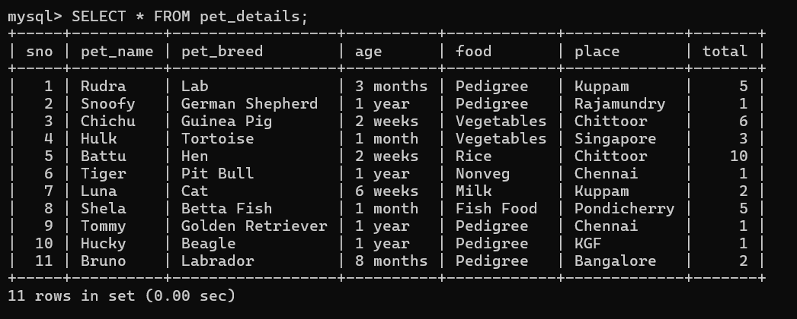
4. SELECT COMMAND:

SELECT * FROM pet_details;
OUTPUT:
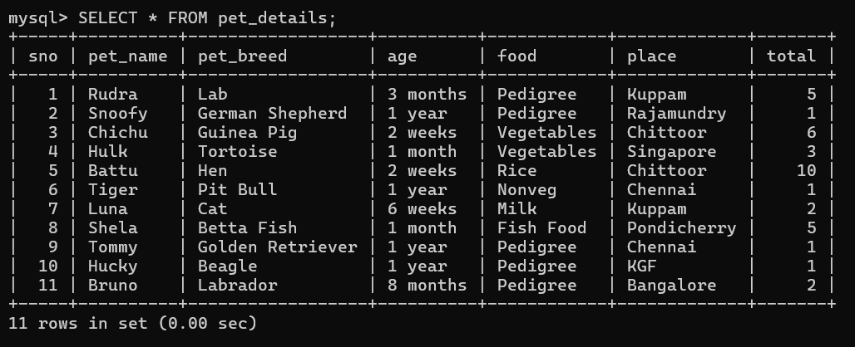

RESULT: Data Manipulation Language (DML) Commands such as INSERT, SELECT are performed

